KENDRIYA VIDYALAYA NO.5, BHUBANESWAR
LIST OF GOVT. HOLIDAYS AND RESTRICTED HOLIDAYS TO BE OBSERVED DURING THE YEAR 2020
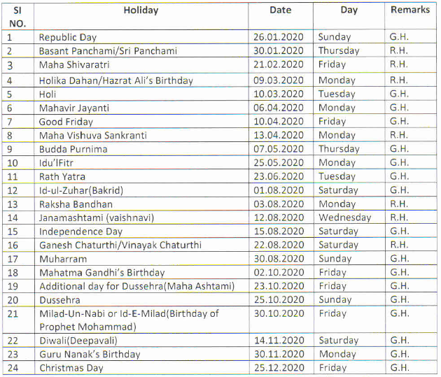

PRINCIPAL
KV NO.5 BHUBANESWAR

